**Hello World RESTful Web Service**    
  
package com.cognizant.springlearn.controller;  
  
import org.slf4j.Logger;  
import org.slf4j.LoggerFactory;  
import org.springframework.web.bind.annotation.GetMapping;  
import org.springframework.web.bind.annotation.RestController;  
  
@RestController  
public class HelloController {  
  
 private static final Logger *LOGGER* = LoggerFactory.*getLogger*(HelloController.class);  
  
 @GetMapping("/hello")  
 public String sayHello() {  
 *LOGGER*.info("Start");  
 String message = "Hello World!!";  
 *LOGGER*.info("End");  
 return message;  
 }  
}

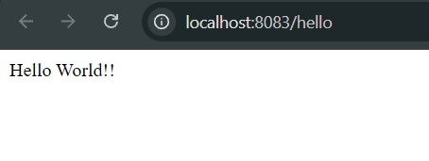

package

**REST - Country Web Service**

com.cognizant.springlearn.controller;  
  
import com.cognizant.springlearn.Country;  
import org.slf4j.Logger;  
import org.slf4j.LoggerFactory;  
import org.springframework.context.ApplicationContext;  
import org.springframework.context.support.ClassPathXmlApplicationContext;  
import org.springframework.web.bind.annotation.RequestMapping;  
import org.springframework.web.bind.annotation.RestController;  
  
@RestController  
public class CountryController {  
  
 private static final Logger *LOGGER* = LoggerFactory.*getLogger*(CountryController.class);  
  
 @RequestMapping("/country")  
 public Country getCountryIndia() {  
 *LOGGER*.info("START - /country");  
 ApplicationContext context = new ClassPathXmlApplicationContext("country.xml");  
 Country country = context.getBean("country", Country.class);  
 *LOGGER*.info("END - /country");  
 return country;  
 }  
}

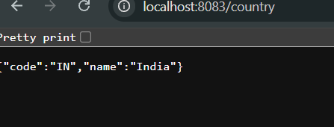

package

com.cognizant.springlearn.controller;  
  
**REST - Get country based on country code**   
  
import com.cognizant.springlearn.Country;  
import com.cognizant.springlearn.service.CountryService;  
import org.slf4j.Logger;  
import org.slf4j.LoggerFactory;  
import org.springframework.beans.factory.annotation.Autowired;  
import org.springframework.web.bind.annotation.*;  
  
@RestController  
public class CountryController {  
  
 private static final Logger *LOGGER* = LoggerFactory.*getLogger*(CountryController.class);  
  
 @Autowired  
 private CountryService countryService;  
  
 @GetMapping("/countries/{code}")  
 public Country getCountry(@PathVariable String code) {  
 *LOGGER*.info("START - /countries/{}", code);  
 Country country = countryService.getCountry(code);  
 *LOGGER*.info("END - /countries/{}", code);  
 return country;  
 }  
}

package com.cognizant.springlearn.service;  
  
import com.cognizant.springlearn.Country;  
import org.springframework.context.ApplicationContext;  
import org.springframework.context.support.ClassPathXmlApplicationContext;  
import org.springframework.stereotype.Service;  
  
import java.util.List;  
  
@Service  
public class CountryService {  
  
 public Country getCountry(String code) {  
 ApplicationContext context = new ClassPathXmlApplicationContext("country.xml");  
 List<Country> countryList = context.getBean("countryList", List.class);  
  
 return countryList.stream()  
 .filter(country -> country.getCode().equalsIgnoreCase(code))  
 .findFirst()  
 .orElse(null);  
 }  
}

